# Media Analysis - ‘I am not here to take your job,’ ChatGPT tells Frankly Speaking host _Updated 20 March 2023

## Short Summary

In summary, ChatGPT emphasizes its role as a tool, highlighting the responsibility of humans, developers, policymakers, and users alike.

## Summary

In summary, ChatGPT is an AI language model developed by OpenAI. Its purpose is to generate text based on user inputs, while acknowledging the responsibility of humans in determining its impact. The technology has both potential benefits and concerns related to privacy, bias, and job displacement, which require responsible development and regulation.

## Question 1

In the context of media coverage on ChatGPT, the framing can vary depending on the outlet s focus and perspective. Media outlets may emphasize different aspects such as the technology itself, its implications for society, potential ethical concerns, or the response from various stakeholders. Metaphors are common in language, including media discourse. When discussing ChatGPT, metaphors might include 1. Language genie - highlighting the AI s ability to understand and generate human-like language. 2. Communication revolution - emphasizing how ChatGPT is changing the way people interact through technology. 3. Ethical specter - using a metaphor to suggest that ChatGPT raises ethical questions that may loom large in society. Overall, the media framing of public discussion around ChatGPT would likely involve a mix of technical descriptions, commentary on societal implications, and the use of metaphors to convey complex ideas more effectively.

## Question 2

The perspectives and aspects that are being widely covered in discussions about AI technology like ChatGPT include 1. **Advancements and capabilities** The focus on improved natural language processing, context-awareness, and potential applications. 2. **Impacts on industries and job market** Debates on how AI may disrupt traditional roles, create new jobs, or exacerbate existing inequalities. 3. **Ethics and regulation** Discussions about the responsibility of developers, policymakers, and businesses in ensuring AI is used ethically and with proper oversight. 4. **Privacy concerns** The spotlight on data privacy issues related to AI-generated data collection and potential misuse. 5. **Bias and fairness** Debates around the need for AI algorithms to be unbiased and fair, especially when it comes to sensitive applications like hiring or lending decisions. On the other hand, some aspects that may be under-discussed include 1. **Technical intricacies** The complexity of AI models and their underlying mathematics might not be as widely covered as its impact. 2. **Research and development funding** The extent to which governments, private companies, or philanthropic organizations are investing in AI research might not receive equal attention. 3. **AI literacy and education** Efforts to increase public understanding of AI technology, the potential risks and benefits, and how to critically evaluate AI-generated content may be under-emphasized. Overall, it s important to recognize that discussions on AI cover a wide range of perspectives, but there will always be areas that receive more or less attention depending on current priorities and trends.

## Question 3

The Arabic World is mentioned as the context for an interview where Arab News asks about the features that may be added to ChatGPT. It does not specify how the Arabic World is leveraging AI, other than in the context of this article s discussion.

## Question 4

The final message is that AI s impact on humanity depends on responsible use, collaboration, and ethical considerations.

## Sentiment

The sentiment is 0.0

## Entities

Microsoft, Edge, Google, OpenAI, Katie Jensen, Frankly Speaking, AI, Sam Altman, Bing, Arab News, Baidu, ChatGPT, Jensen, Meta, Amazon, Bard

## Highlights

#c885da#f9cd59#7cc867#fb5b89#69aff0

## Wordcloud for #c885da Highlights

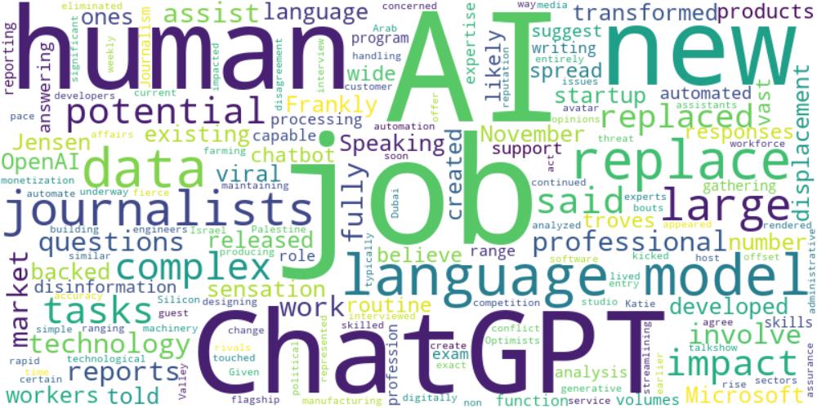

Top 10 words:

- AI: 18

- jobs: 10

- language: 10

- ChatGPT: 9

- human: 9

- job: 7

- data: 7

- replace: 7

- journalists: 7

- large: 6

## Wordcloud for #f9cd59 Highlights

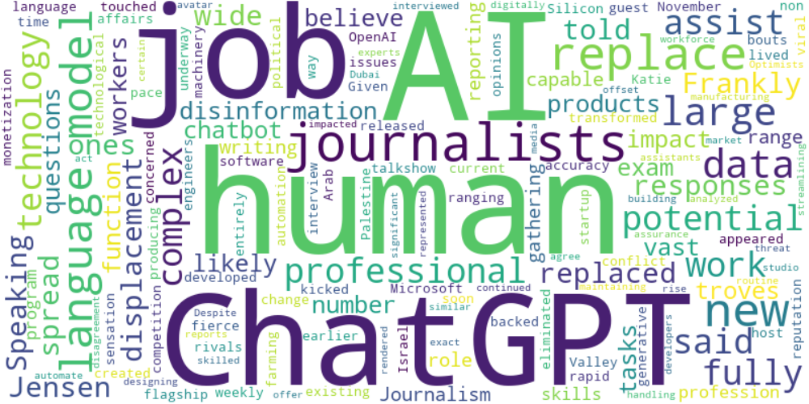

Top 10 words:

- AI: 10

- human: 9

- ChatGPT: 7

- journalists: 7

- language: 6

- replace: 6

- jobs: 4

- large: 4

- data: 4

- like: 3

## Wordcloud for #7cc867 Highlights

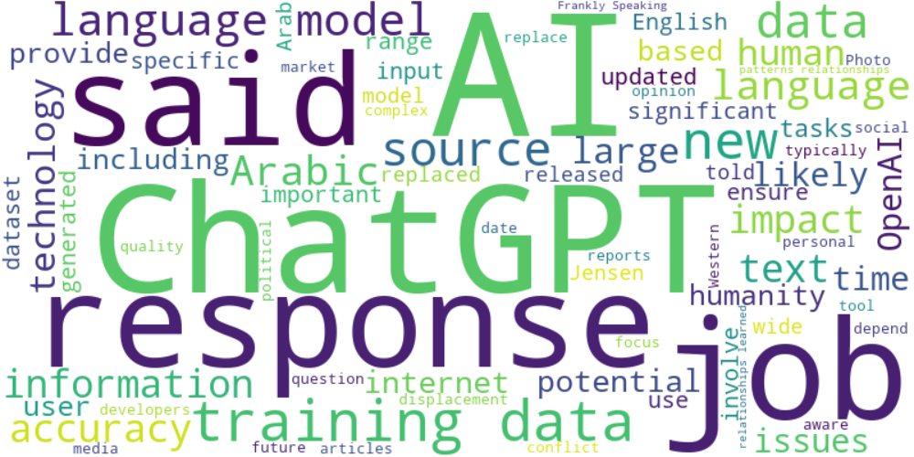

Top 10 words:

- AI: 27

- data: 24

- ChatGPT: 20

- language: 18

- training: 16

- responses: 14

- said: 14

- jobs: 9

- sources: 9

- new: 8

## Wordcloud for #fb5b89 Highlights

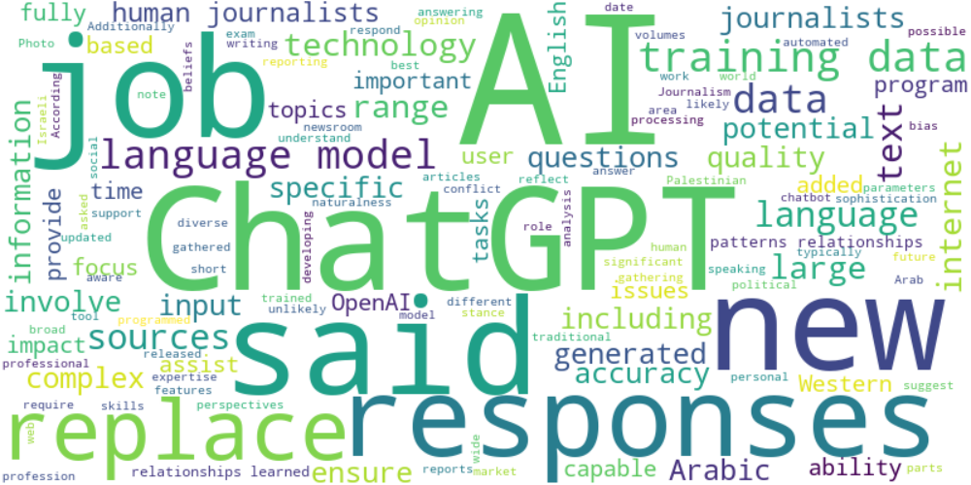

Top 10 words:

- AI: 22

- data: 17

- language: 14

- ChatGPT: 13

- said: 11

- responses: 10

- training: 10

- replace: 9

- journalists: 8

- jobs: 7

## Wordcloud for #69aff0 Highlights

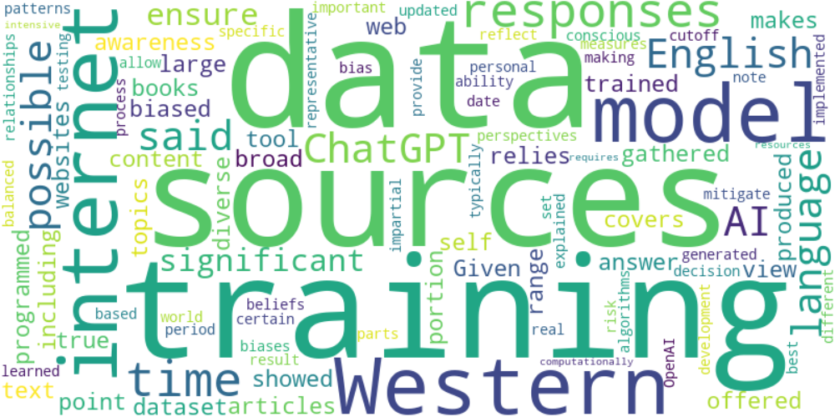

Top 10 words:

- data: 5

- sources: 4

- training: 4

- Western: 3

- internet: 3

- model: 3

- responses: 3

- time: 3

- English: 2

- possible: 2